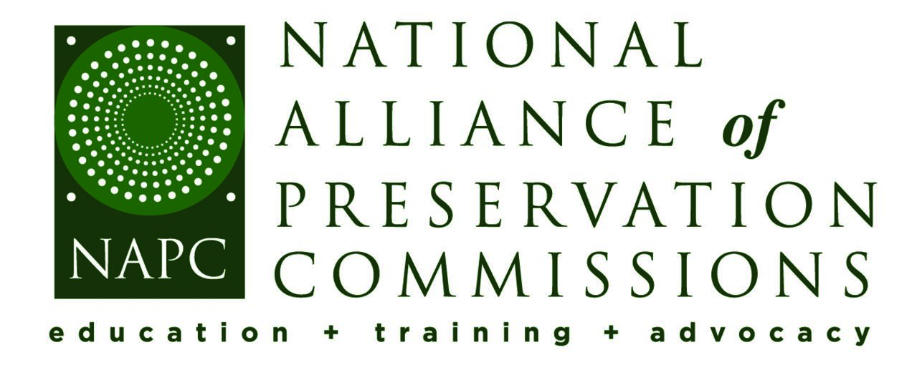
Section 106 Under Threat:
What These Proposed Changes Mean for Preservation at the Local Level

Additional Resources
- All Presentation Slides
- NAPC Messaging Guide for Local Preservation Programs
- NAPC’s Advocacy Webpage
- Section 106 Handout for Local Commissions
- Template Letter or Email to a Mayor, City Council Member, or Other Local Official
- National Historic Preservation Act & Local Commissions
- Communicating with Elected Officials (Excerpt from NAPC’s Messaging Guide)
- From Abbey Christman’s Presentation:
  - Proclamation Regarding Proposed Changes to Federal Historic Preservation Regulations
  - Sample OIRA Meeting Request Memo
  - Sample Section 106 Commission Briefing
  - Section 106 Comment Prep Guide

