
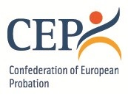

Governance oversight and accountability mechanisms in Probation and Parole.
Compare and contrast Europe and USA
(1st series)
18 September 2025
8.00-10.00 CDT (USA participants)
15.00-17.00 CET (EU participants)

AGENDA

8.00-8.10 Welcome and opening
15.00-15.10 Iuliana Carbunaru, CEP
Veronica Cunningham, APPA

8.10-8.20 About CEP and APPA
15.10-15.20 Mirka Jakesova, CEP
Veronica Cunningham, APPA

8.20-8.50 Governance oversight and accountability mechanisms
15.20-15.50 in Europe
Iuliana Carbunaru, Ministry of Justice, National Probation Administration, Romania

8.50-9.40 Governance oversight and accountability mechanisms in the
15.50-16.40 USA
Chris Cirrito, Office of the Independent Auditor, Texas, USA

9.40-9.55 Q&A session
16.40-16.55

10.00/17.00 Closing

